VILLALUNA JENNIFER
BSIT 3F2

- CLASS DIAGRAM
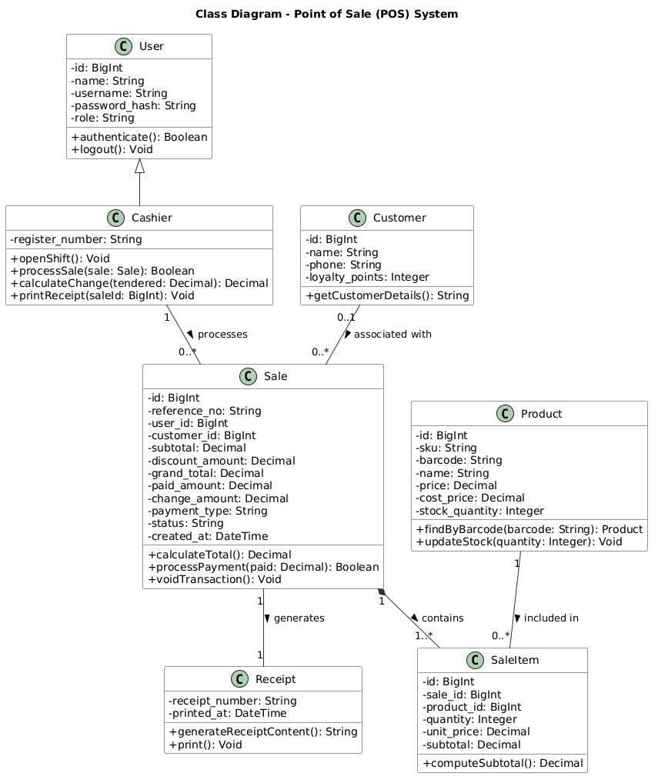

This class diagram illustrates the object-oriented structure of the Point of Sale (POS) System. It models the core entities involved in checkout transactions, including Cashier (inherited from User), Product, Customer, Sale, SaleItem, and Receipt.

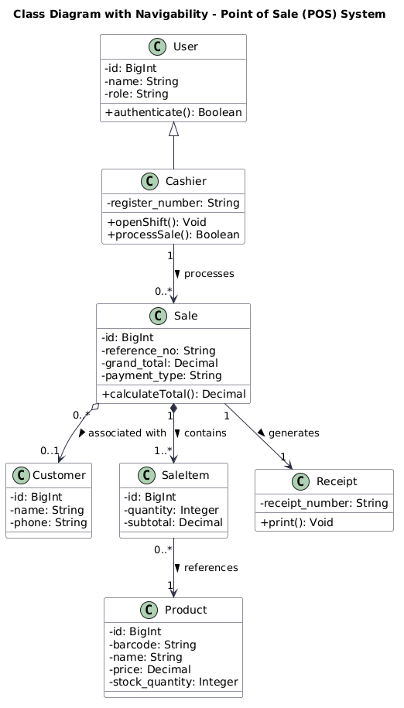
- Sample class with navigability arrows

This class diagram illustrates the object-oriented architecture and navigability of the Point of Sale (POS) System. The directed arrows (-->, *-->, o-->) indicate the traversal direction between related entities:

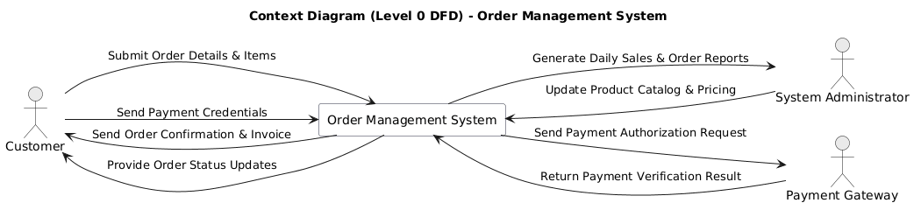
- Sample Diagram 0
This Context Diagram (Level 0 DFD) defines the operational boundary of the Order Management System. It highlights the data flows between the central system and three primary external entities:

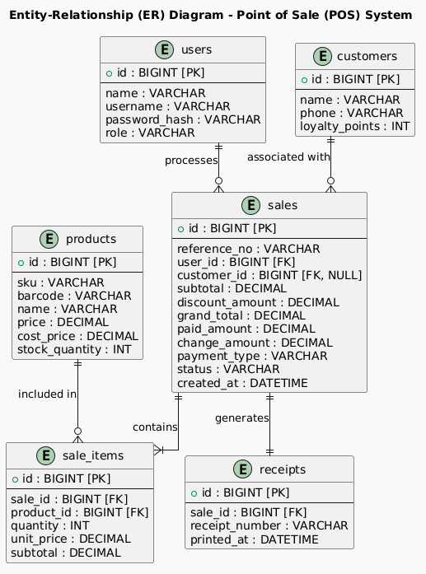
- ER Diagram
This ER diagram models the relational database schema for the POS module, highlighting primary keys (PK), foreign keys (FK), and cardinalities using standard Crow's Foot notation. It defines how data flows and connects across the MySQL database tables.

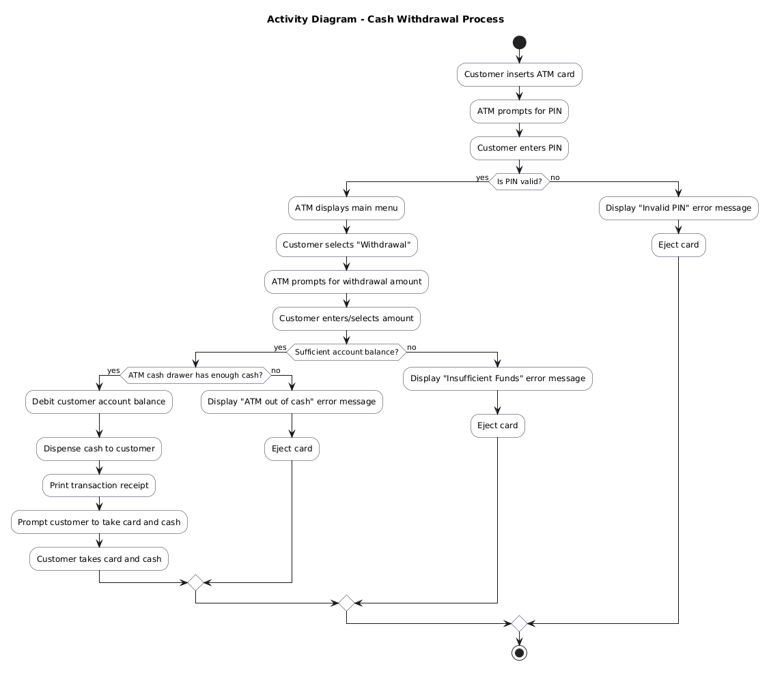
- Activity Diagram Example For Withdrawal
This Activity Diagram models the step-by-step workflow of a Cash Withdrawal Process at an automated teller machine (ATM). It details the primary operational steps and decision points involved:

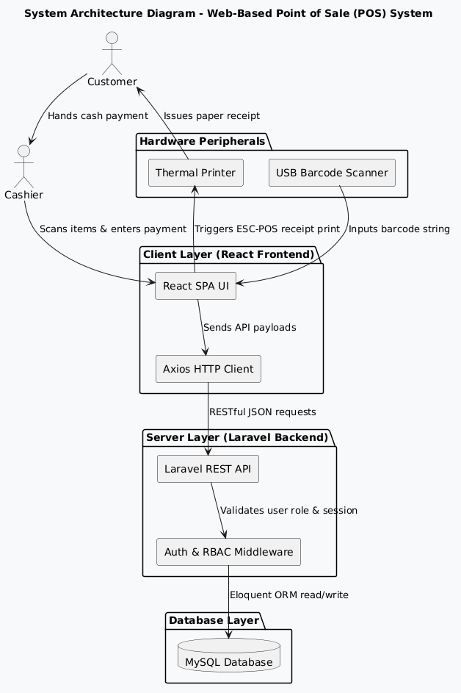
- Structured Diagram

This system architecture diagram illustrates the decoupled multi-tier layout of the Web-Based Point of Sale (POS) System. It maps out how the front-end user interface communicates with the backend API and database, alongside physical hardware peripherals:

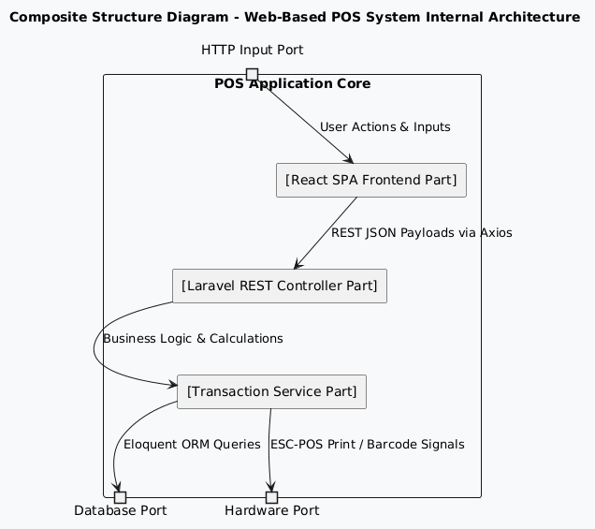
- Composite Structure Diagram

This composite structure diagram details the internal structural parts and communication ports of the Web-Based Point of Sale (POS) System. It models how internal components collaborate within the application boundary:

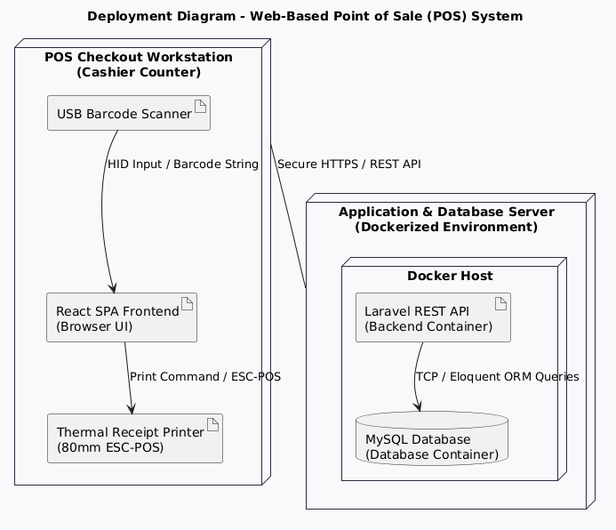
- Deployment Diagram

This deployment diagram illustrates the physical and virtual hardware-software topology of the Web-Based Point of Sale (POS) System. It details how the system is distributed across runtime environments:

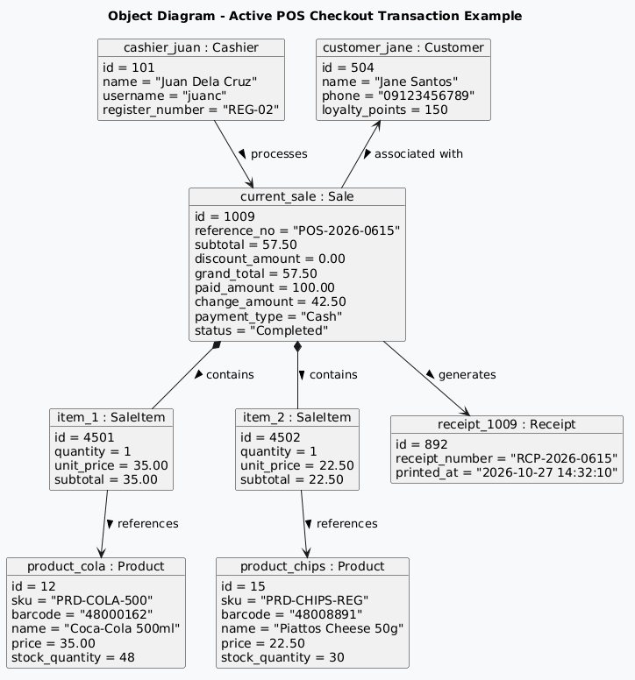
- Object Diagram
This object diagram illustrates a concrete runtime snapshot of a completed checkout transaction within the POS module. It demonstrates the specific instantiation of system entities with sample data values (such as cashier details, customer loyalty records, scanned product items, cash tender calculations, and transaction references) and their active links at a given moment during system operation.

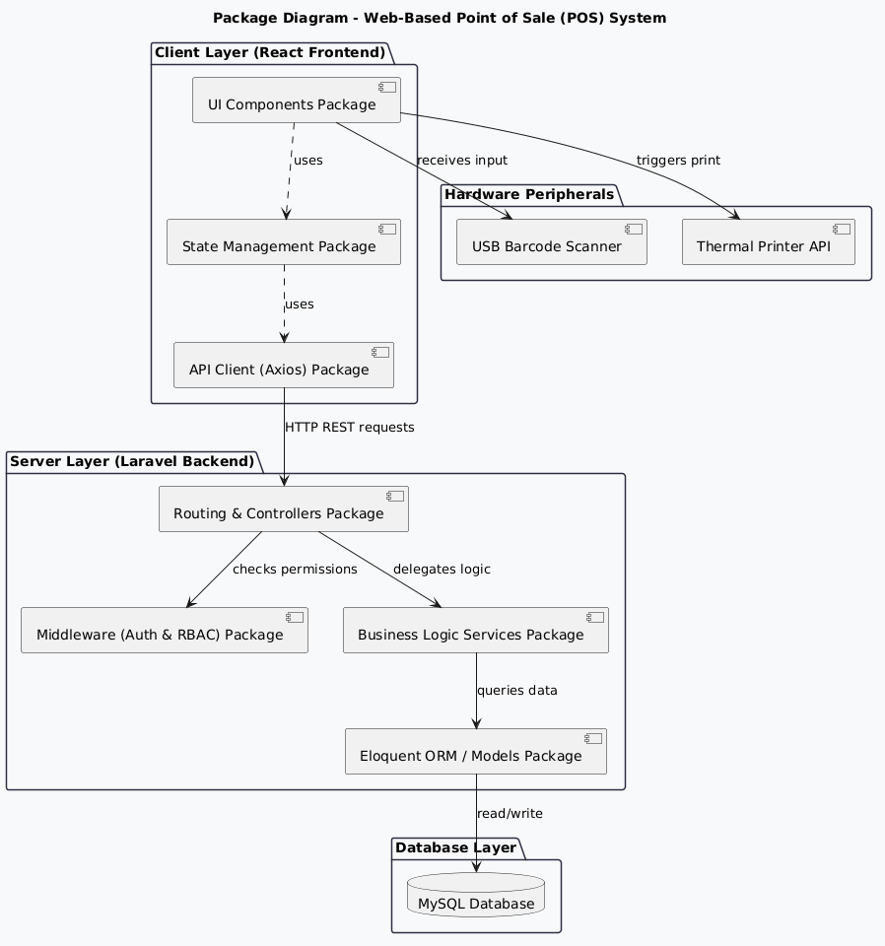
- Package Diagram
This package diagram illustrates the modular architecture and hierarchical dependencies of the Web-Based Point of Sale (POS) System. It organizes the software into distinct logical namespaces.

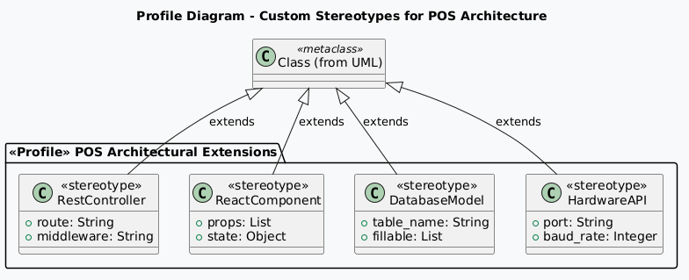
- Profile Diagram

This profile diagram defines custom UML stereotypes tailored for the Web-Based Point of Sale (POS) System architecture. It extends standard UML metaclasses to categorize and annotate specialized system components, such as <<RestController>> for backend API endpoints, <<ReactComponent>> for frontend UI modules, <<DatabaseModel>> for Eloquent ORM database entities, and <<HardwareAPI>> for peripheral integrations like barcode scanners and thermal receipt printers.

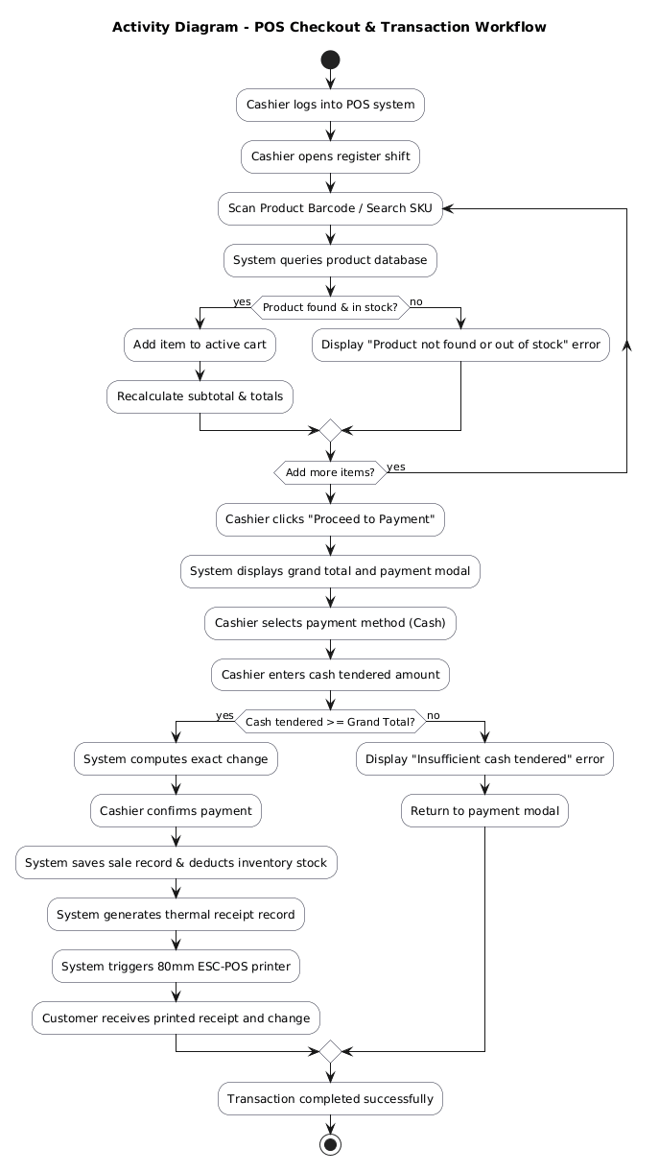
- Activity Diagram
This activity diagram illustrates the operational workflow of the Point of Sale (POS) checkout module. It outlines the sequential steps and conditional validation branches performed by the cashier and the system during a sales transaction

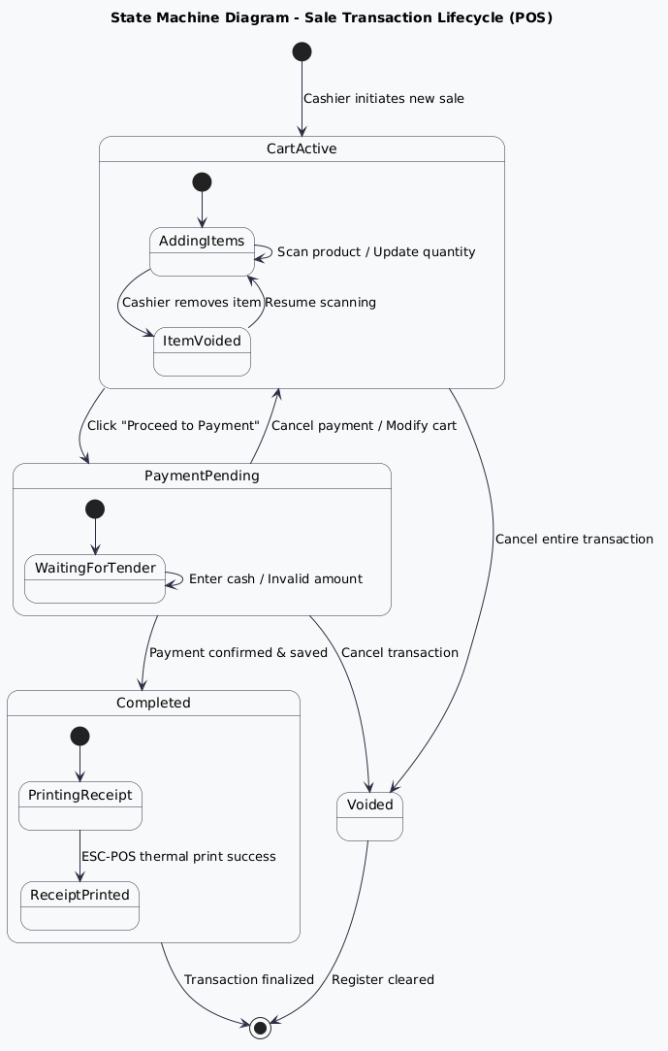
- State Machine Diagram
This state machine diagram models the dynamic lifecycle states of a Sale Transaction within the POS module. It details the various operational states and the triggering events that cause transitions between them:
- CartActive: The initial state where items are scanned, quantities are modified, or items are voided.
- PaymentPending: Triggered when proceeding to checkout, awaiting valid cash tender input or payment confirmation.
- Completed: The final successful state where the transaction is saved to the database, inventory stock is deducted, and the thermal receipt is successfully printed.
- Voided: An alternative termination state where an active or pending transaction is cancelled before final payment confirmation.

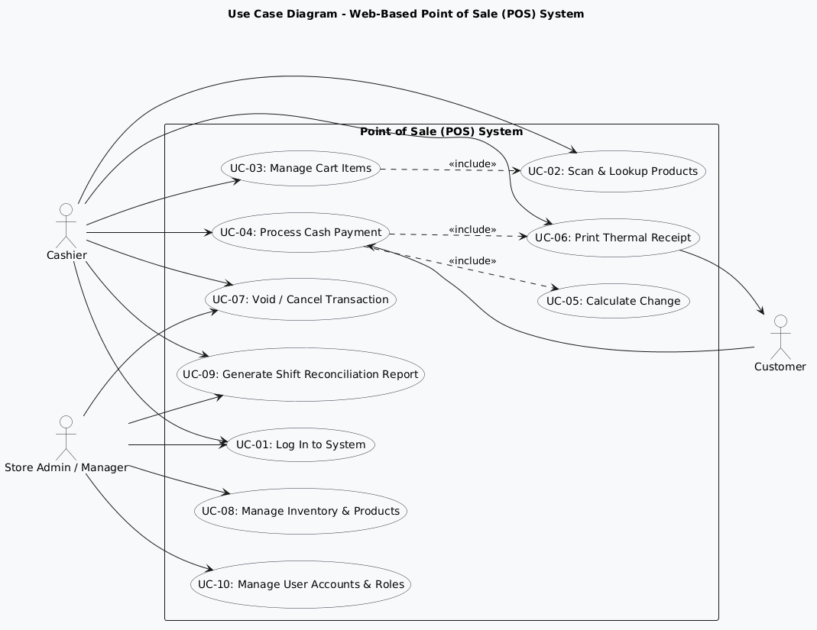
- Use Case Diagram
This Use Case Diagram illustrates the functional boundaries and primary actor interactions within the Web-Based Point of Sale (POS) System. It outlines how primary users utilize system features:

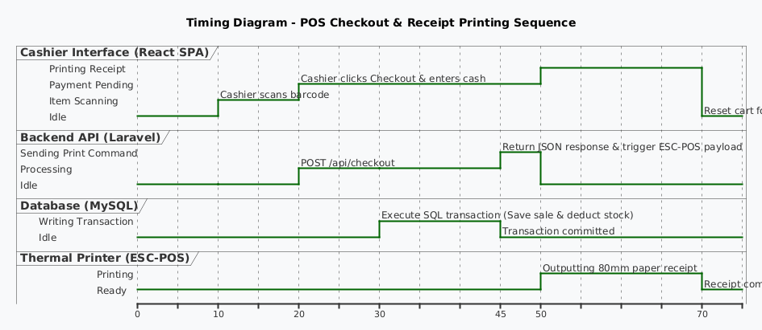
- Timing Diagram
This timing diagram illustrates the precise state changes of critical system components over time ($t=0$ to $t=70$) during a POS checkout sequence:
$t=0\text{–}10$ (Idle to Scanning): The React SPA interface shifts from an Idle state to Item Scanning as the cashier scans barcodes.

$t=20\text{–}45$ (API & Database Processing): Upon entering payment details, the React frontend transitions to Payment Pending while sending an asynchronous REST request to the Laravel API (Processing). The API invokes MySQL (Writing Transaction), committing sales logs and deducting stock quantities via Eloquent ORM.

$t=45\text{–}70$ (Receipt Generation & Completion): Once the database commit succeeds, the API returns a response to trigger the ESC-POS driver. The Thermal Printer transitions from Ready to Printing to output the receipt. After completion ($t=70$), all components return to their default Idle/Ready states for the next customer.

